Name: kimheeseo Date: 2022.10.06

**Article Summary Practice   
(Paper #1)**

Preparing for an Annotated Bibliography

|  |
| --- |
| Instructions (설명) |

1. *Copy and paste the information from the week 2 Article Annotation exercise with the* ***Before Reading*** *and* ***After Skimming*** *tables.*
2. *In* ***Article Summary****, add a 1 paragraph summary (at least 5 sentences) of your article using the notes from #1.*

|  |  |
| --- | --- |
| *Article Information* | |
| Title | Learned Decimation for Neural Belief Propagation Decoders : Invited Paper |
| Author (s) | Andreas Buchberger, Christian Häger, Henry D. Pfister, Laurent Schmalen, Alexandre Graell i Amat |
| Journal Title | ICASSP 2021 - 2021 IEEE International Conference on Acoustics, Speech and Signal Processing (ICASSP) |
| Year of Publishing | 06-11 June 2021 |
| Volume/Issue |  |
| Pages | p.5 |
| Keywords / Search Terms | LDPC, NBP(neural belief propagation), decimation |

|  |
| --- |
| Article Notes (a.k.a. Annotation) |

|  |  |
| --- | --- |
| **Before Reading the Article** | |
| Question | Answer |
| What key information are you hoping to get from this paper?  Or  What questions are you expecting to be answered by reading this paper? | **Recent research trend is to use deep learning in many research field. Therefore, there is a question of how to use the neural network architecture. What algorithms or deep neural network method(architecture) do researcher use?** |
|  |  |
| Which section of the paper is the best place to find that information (or answer those questions)? | **‘section 3. Decimated neural belief propagation decoder’ deals with the neural network(NN), an important part of the paper. Total decoding process consists of a two steps, ‘List-based Decimation Stage’ and ‘Learned Decimation Stage’, and each stage process and order are described.** |
|  |  |
| How does this paper relate to other research/articles in the field?  *(Is the paper a foundation paper that explains basic methods that are now used by all researchers, is the paper using a novel technique or perspective from prior research?*) | **Recent research trend is using deep learning. (in the paper) In particular, deep learning is used to improve performance and complexity. The main goal of this paper is to improve complexity issue, so I think it will be helpful for future research. This paper is using a novel technique.** |

|  |  |
| --- | --- |
| **After skimming the article**  ( reading abstract, figures, reading the beginning and/or end of key paragraphs/section ) | |
| Question | Answer |
| What info in this article is still useful to you? | **My interest subject is channel coding with deep learning. So, It was helpful because it was one of the various methods of deep learning. (In other paper) Many researchers focused on check node updates, but it is characterized by focusing on variable nodes in this paper. It is interesting part of this paper.** |
|  |  |
| What is the purpose or aim of this study(the research done in this paper)? | **adjust tradeoff of performance and complexity. Reducing complexity compared to previous studies (paper or research), and making similar performance as possible, i.e. adjusting tradeoff appropriately.** |
|  |  |
| What is/are the main/key outcomes (results/conclusions)? | **adjust tradeoff of performance and complexity.** |
|  |  |
| What was/were important aspect(s) of their procedure or methods? | **Since researcher don't know sign, researcher set it to +- infinity as a method for decimation and used 'learned decimation stage' to use NN(neural network). In particular, the parameters were optimized through deep learning. However, limitation thing is that It didn't mention what parameter is specifically, but I think it's weight. And it had other limitation thing that there was no standard for how many decimation times(number) each of the two stages.** |
|  |  |
| Were there any limitations of the study? What were those limitations? *(perspectives the research didn’t cover, missing or unclear information, . . .)* | **‘Pruning neural belief propagation decoders’ is a paper that studies similar methods. The performance was compared with 'previous paper', a similar study. But the performance did not seem to be compared under the same conditions(situation).** |

|  |
| --- |
| Article Summary |

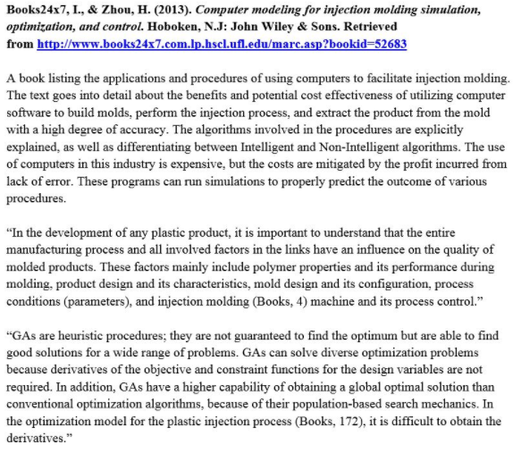

*After rereading the article and using the notes above, write* ***one paragraph*** *summarizing (using paraphrased sentences) the important information in the article. Please be sure to follow appropriate paragraph formatting.*

Using IEEE Style or (the Journal style your article is from), place your article’s bibliographical information before the first line of your paragraph. (like the example to the left)

|  |
| --- |
| Andreas Buchberger, Christian Häger, Henry D Pfister, Laurent Schmalen, et al. Learned decimation for neural belief propagation decoders. arXiv preprint arXiv:2011.02161, 2020  Belief Propagation (BP) decoding algorithm is one of the main Low-density parity-check code(LDPC) decoding algorithm. BP decoding algorithm can obtain decoding performance close to the Shannon limit when code length is very long. Recently, deep learning has made tremendous progress and has been applied to various fields. Particularly, it is applied to the communication fields (e.g. channel coding, physical layer, network system and so on) and solves difficult problems. In 2017, channel coding’s frontier researcher ‘Eliya Nachmani’ is first person to apply deep learning to channel coding. The method he proposed is ‘neural belief propagation (NBP)’ or ‘weighted BP decoding (WBP)’. Its method offsets effect of a short cycle in graph that adversely affects performance by assigning different weights to the edges. So, setting single coefficient to all messages improves performance, but it is difficult to apply it to hardware due to complexity. Then, performance and complexity have a trade-off relationship. To reduce complexity, some researchers suggested many methods. ‘Andreas’ proposed two stages of decimation. It consists of ‘a list-based decimation stage’ and ‘a learned decimation stage’. In first stage, It runs a conventional NBP decoder for maximum iteration. And it identifies the least reliable VN and decimate it to +-infinity. Because its value means a message of low importance in decoding process. Choosing correct sign is essential as ‘correct sign’ will aid convergence. But Since it is difficult to know sign value, it is proceeded by decimating each value with +- infinity value. Repeat its process a set number of times and output a list of codeword candidates. In second stage, It runs a conventional NBP decoder for maximum iteration. And it uses a Neural Network (NN) to decide to which value each VN is decimated to. Because in previous stage ‘a list-based decimation stage’, performance is improved, but complexity is increased a lot, so it needs to be improved by NN. So, NN takes the incoming messages to the node and channel LLR as input and output an absolute value. In last step, Among output values, the largest value becomes estimated codeword and evaluate performance by comparing sent messages with estimated values. In conclusion section, result are shown by simulation. It shown that new method can significantly improve the performance of BP and NBP. But It has limitation that it can be applied to short block code. |
|  |

